Interview question: to build an increment and decrement counter

Follow Up: if

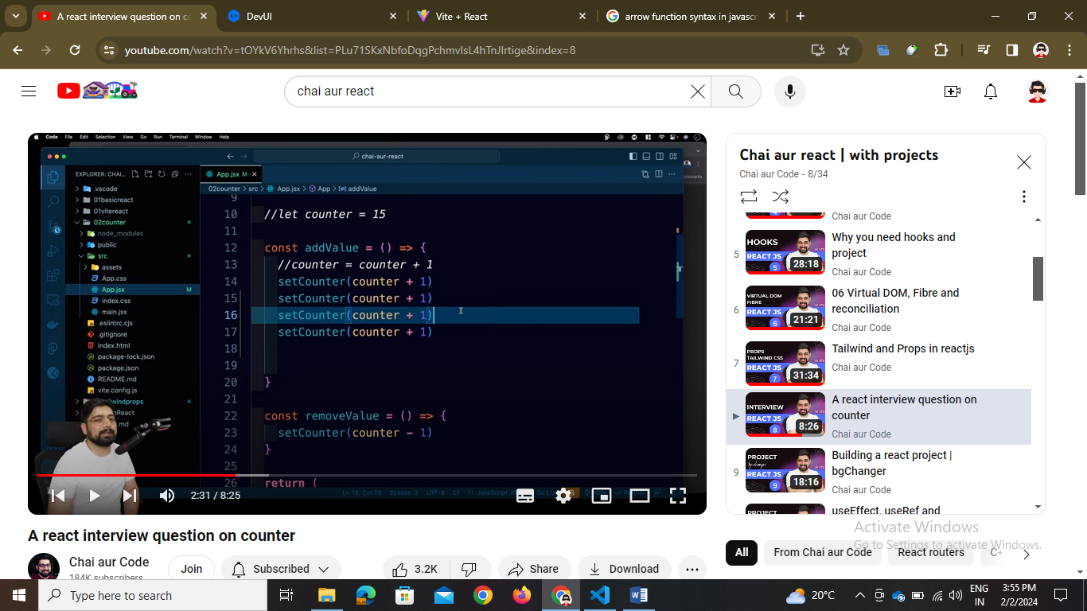

If setCounter ko 3 se 4 times likh diya then kya hoga

No will not increase 4 times it will do one time only as fibre algo will create a batch of same statements and send them

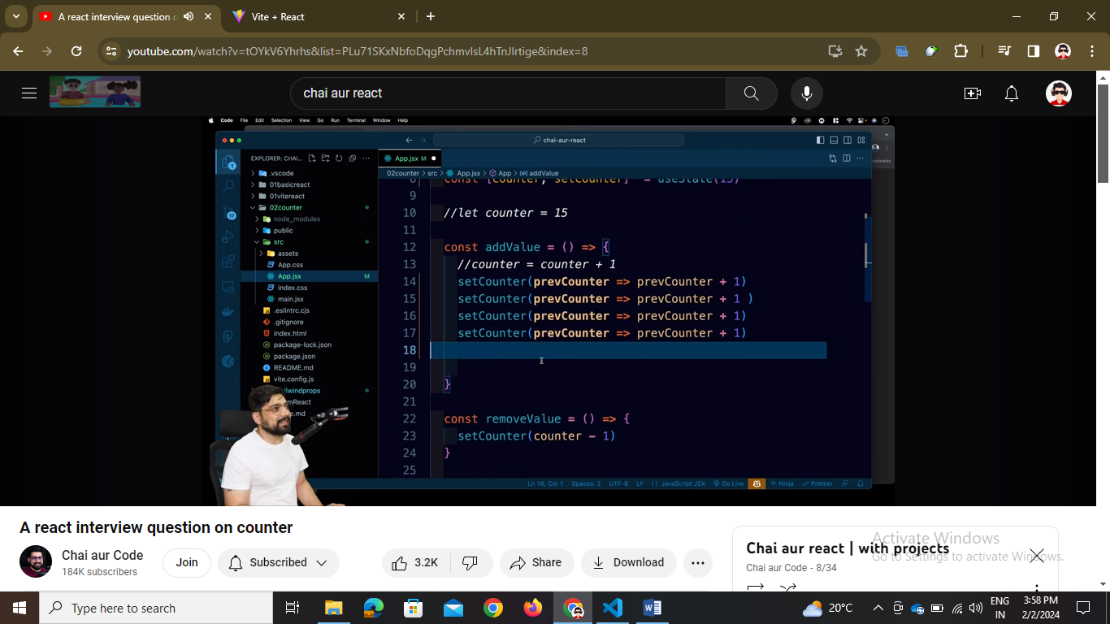

// but if we want to do that 4 times then use callback function as in this callback occurs after one function is over not gone in batch fetch the counter state by prevCounter and then update by 1